Detection 1 – SSH Brute Force
Objective
Detect repeated failed SSH login attempts against the Ubuntu server.

Attack Flow
Kali
↓
SSH Login Attempts
↓
Ubuntu SSH Logs
↓
Wazuh Agent
↓
Wazuh Manager
↓
Rule Match
↓
Dashboard Alert

MITRE ATT&CK
Field | Value
Technique | T1110
Name | Brute Force
Tactic | Credential Access

Detection Logic
Wazuh already contains rules for SSH authentication failures.
We will verify these built-in detections before creating any custom rules.

Step 1 – Confirm SSH is running
On Ubuntu Target:
sudo systemctl status ssh
Expected:
Active: active (running)

Step 2 – Generate failed logins
From Kali:
ssh wronguser@192.168.30.40
or
ssh admin@192.168.30.40
Enter an incorrect password 5–10 times.

Step 3 – Verify on the Manager
On the Wazuh server:
sudo tail -f /var/ossec/logs/alerts/alerts.json
You should see SSH-related alerts.

Step 4 – Verify in Dashboard
Search:
agent.name:"ubuntu-target"
or
rule.groups:sshd
or
rule.description:*authentication*

Step 5 – Capture Evidence
Take screenshots of:
- Kali terminal with failed SSH attempts.
- Wazuh Dashboard showing the alert.
- Alert details (rule ID, severity, MITRE mapping).
These will go into your report.

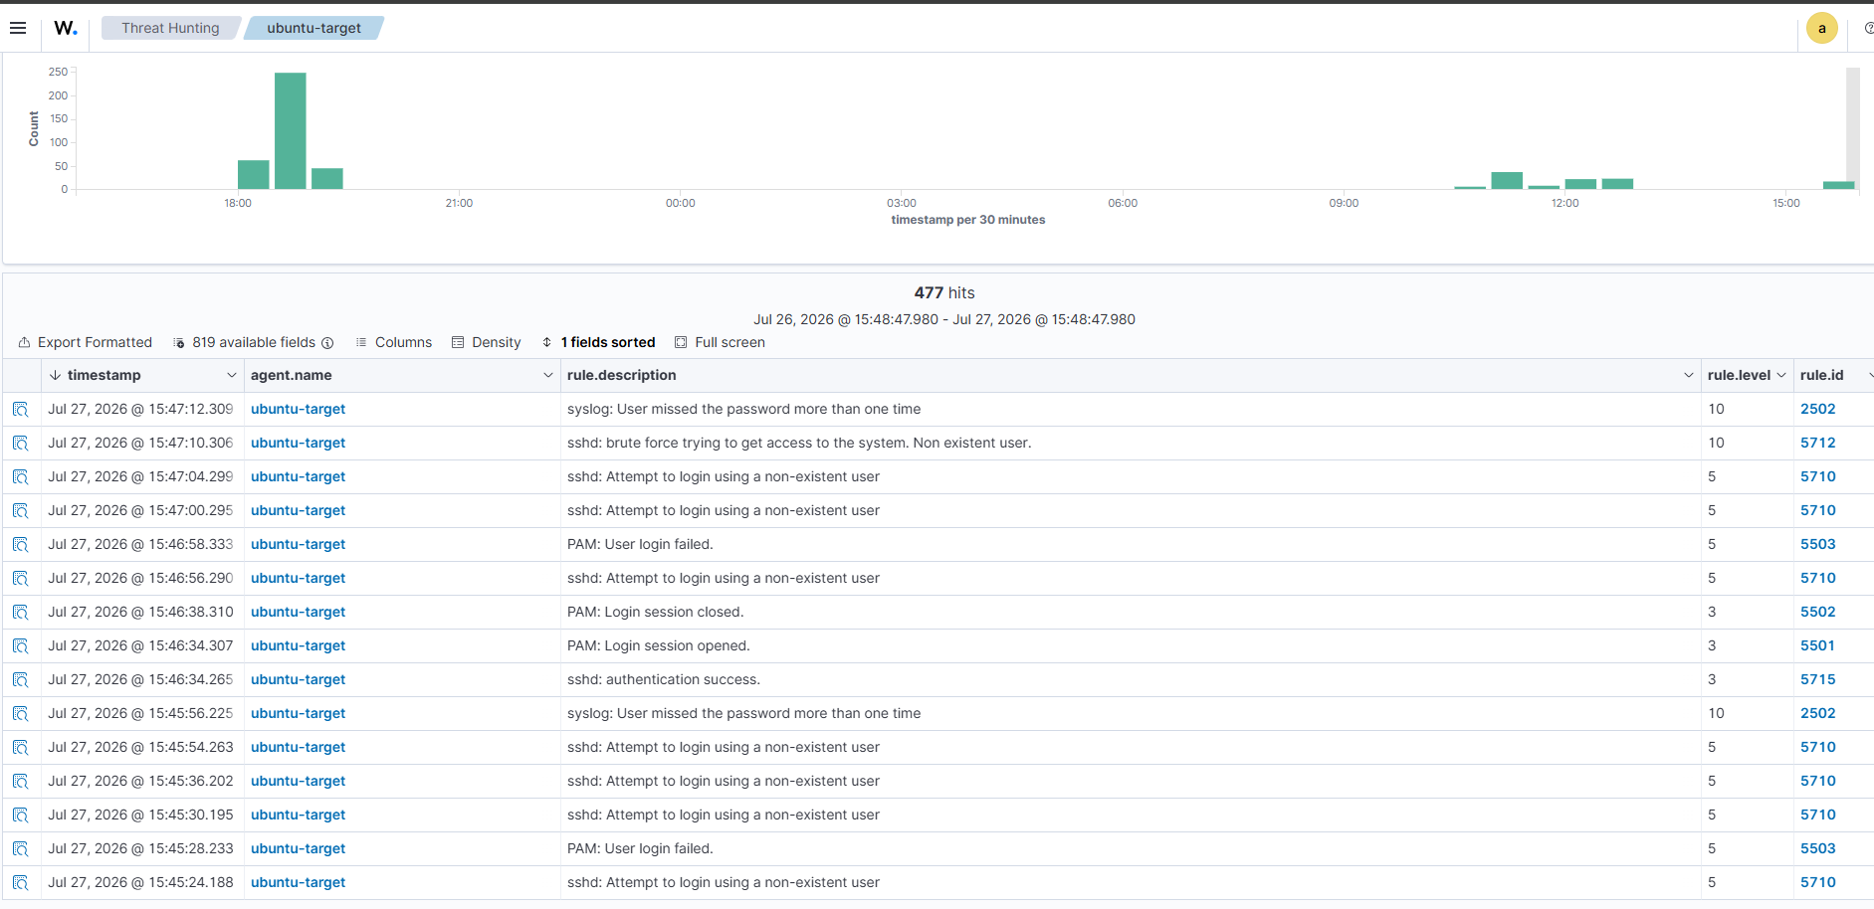

Phase 6 – Detection 2
Now we move to the web application, since your project is centered on DVWA.
Detection 2 – SQL Injection
Objective
Detect SQL injection attempts against DVWA.
Test
From Kali or Windows 11, open DVWA and navigate to:
DVWA → SQL Injection
Set DVWA security to Low.
In the input field, enter:
' OR 1=1#
Then try:
1' UNION SELECT user,password FROM users#
Before creating any custom rules
We first need to verify whether these payloads appear in the Apache access log.
On the Ubuntu Target, run:
sudo tail -f /var/log/apache2/access.log

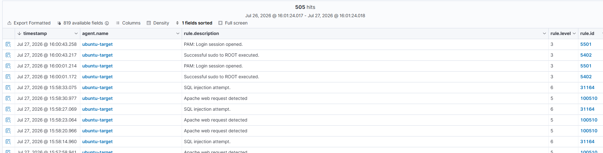

Next Detection
Now we should move to XSS (Cross-Site Scripting).
We'll verify whether Wazuh already detects it before writing any custom rules.
Go to:
DVWA
↓
XSS (Reflected)
Payload:
<script>alert(1)</script>
Then:
<img src=x onerror=alert(1)>
After running the payloads, check Threat Hunting or MITRE Events.
If Wazuh already raises an alert, we'll use the built-in rule.
If not, we'll create one custom XSS rule.
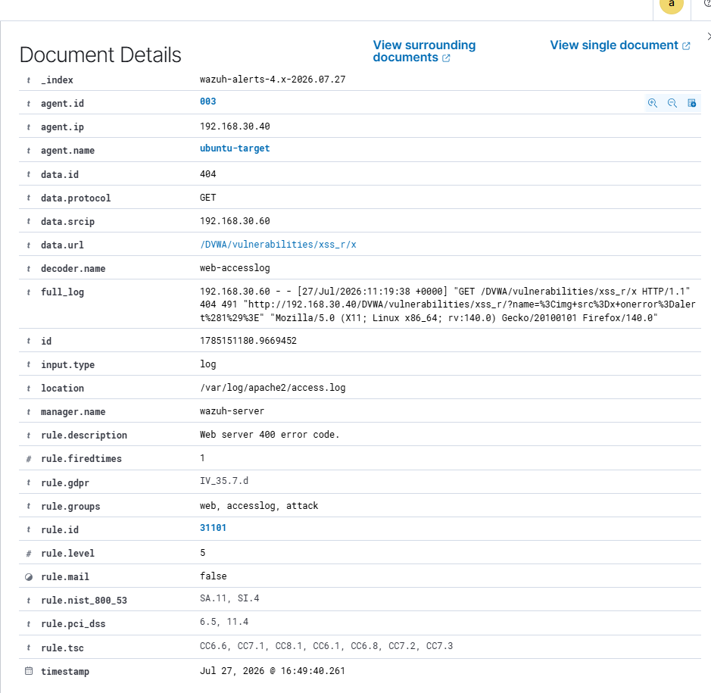

XSS Reflected
Step 1: Edit the rules file
On the Wazuh Manager:
sudo nano /var/ossec/etc/rules/local_rules.xml

Step 2: Delete your current XSS section
Delete this entire block:
<group name="dvwa,xss,">

<rule id="100700" level="10">
<decoded_as>web-accesslog</decoded_as>
...
</rule>

<rule id="100701" level="10">
<decoded_as>web-accesslog</decoded_as>
...
</rule>

</group>

Step 3: Replace it with this
Copy and paste this exactly:
<group name="dvwa,xss,">

<rule id="100700" level="12">
<if_sid>31101</if_sid>
<regex>onerror</regex>

<description>DVWA XSS Attack (IMG onerror)</description>

<mitre>
<id>T1190</id>
</mitre>

<group>web,xss,dvwa,attack,</group>
</rule>

<rule id="100701" level="12">
<if_sid>31101</if_sid>
<regex>%3Cscript</regex>

<description>DVWA XSS Attack (Script Tag)</description>

<mitre>
<id>T1190</id>
</mitre>

<group>web,xss,dvwa,attack,</group>
</rule>

</group>

Step 4: Save
Press:
Ctrl + O
Enter
Ctrl + X

Step 5: Validate
Run:
sudo /var/ossec/bin/wazuh-analysisd -t
It must not show any XML errors.

Step 6: Restart
sudo systemctl restart wazuh-manager

Step 7: Test again
Open DVWA.
Go to:
DVWA
→ XSS (Reflected)
Test:
<img src=x onerror=alert(1)>
Then:
<script>alert(1)</script>

Step 8: Search
In the Dashboard, search:
rule.id:100700
Then:
rule.id:100701

Command Injection

Detection Use Case 4 – Command Injection Detection
Objective
Detect command injection attacks performed against the DVWA Command Injection module using Wazuh custom rules.

Step 1 – Attack Execution
DVWA Module
DVWA → Command Injection
Security Level
Low
Attack Payloads Tested
127.0.0.1; id
127.0.0.1 && whoami
127.0.0.1 | cat /etc/passwd

Step 2 – Apache Log Verification
The Apache access log was monitored using:
sudo tail -f /var/log/apache2/access.log
Observation
Only the following request was recorded:
POST /DVWA/vulnerabilities/exec/ HTTP/1.1
The actual malicious payload (;id, &&whoami, |cat /etc/passwd) was not present in the Apache access log.

Step 3 – Wazuh Log Analysis
The captured request was tested using:
sudo /var/ossec/bin/wazuh-logtest
Result
Phase 2:
Decoder:
web-accesslog
Phase 3:
Rule ID:
31100

Description:
Access log messages grouped
Conclusion
- Wazuh successfully decoded the Apache log.
- No built-in Command Injection detection rule existed.
- Therefore, a custom detection rule was required.

Step 4 – Custom Rule Development
A custom rule group was added to:
/var/ossec/etc/rules/local_rules.xml
Three custom rules were created to detect:
- Semicolon (;)
- Logical AND (&&)
- Pipe (|)
Each rule:
- Used if_sid to extend built-in Rule 31100
- Mapped to MITRE ATT&CK T1059
- Assigned Severity Level 13

Step 5 – Rule Validation
Before restarting the manager, the rule configuration was validated using:
sudo /var/ossec/bin/wazuh-analysisd -t
No XML or rule errors were found.

Step 6 – Wazuh Manager Restart
sudo systemctl restart wazuh-manager
The manager restarted successfully.

Step 7 – Rule Testing
The same command injection payloads were executed again.
The custom rule was tested using:
sudo /var/ossec/bin/wazuh-logtest
Result
Rule ID : 100800

Description:
DVWA Command Injection Attempt (;)

Alert to be generated
This confirmed that the custom rule logic was correct.

Step 8 – Live Monitoring
The Wazuh Dashboard was monitored for Rule IDs:
100800
100801
100802
No live alerts were generated.

Root Cause Analysis
Further investigation showed that the Apache access log only recorded:
POST /DVWA/vulnerabilities/exec/ HTTP/1.1
The POST request body containing:
127.0.0.1;id
127.0.0.1&&whoami
127.0.0.1|cat /etc/passwd
was not logged by Apache's default access log format.
Since Wazuh receives only the Apache access log, it never received the malicious payload during live attacks.

Conclusion
The custom detection rule was successfully developed and validated using wazuh-logtest, demonstrating that the rule logic correctly identifies command injection patterns.
However, live detection was not possible because Apache's default logging configuration does not record HTTP POST request bodies. As a result, the malicious command injection payloads were unavailable to Wazuh during real-time log analysis.

Lessons Learned
- Apache access logs are suitable for detecting attacks where the payload appears in the URL (e.g., SQL Injection, XSS, Directory Traversal).
- Command Injection payloads transmitted in HTTP POST bodies are not captured by Apache's default access logging.
- Rule validation with wazuh-logtest is an effective way to verify detection logic before deployment.
- When the required data is not present in collected logs, the limitation lies in the log source rather than the detection rule itself.

Detection 5 – Malicious File Upload
This is one of the best demonstrations for your project.
MITRE ATT&CK
Technique | Name
T1505.003 | Web Shell

Why this is a good next step
You'll demonstrate:
- Uploading a malicious PHP file.
- Wazuh detecting the uploaded file.
- Detecting access to the uploaded web shell.
- Mapping the event to MITRE ATT&CK.
This is highly relevant to both Red Team and Blue Team scenarios.

Step 1
Go to:
DVWA
→ File Upload
Set:
Security Level = Low

Step 2
Create a simple PHP file.
On the Ubuntu target or Kali, run:
echo "<?php system(\$_GET['cmd']); ?>" > shell.php
This creates a basic web shell for testing.
Use this only within your isolated DVWA lab.

Step 3
Upload:
shell.php
through the DVWA File Upload page.

Stop after the upload
Don't access the shell yet.
First, tell me:
- Did the upload succeed?
- What is the uploaded file path shown by DVWA?
Once we confirm the upload, we'll build detection rules for:
- The file upload event.
- Access to the uploaded shell.
- MITRE ATT&CK mapping.
- Wazuh alerts.
This attack is more valuable for your project than trying to work around the PHP limitation in the File Inclusion module.

Excellent. The upload worked successfully.
The uploaded path is:
/hackable/uploads/shell.php
This is one of the best demonstrations for your project.

Detection 5 – Malicious File Upload
Objective
Detect a malicious PHP web shell upload.
MITRE ATT&CK
Technique | Name
T1505.003 | Web Shell

Step 1 – Verify Apache Log
On the Ubuntu target:
sudo tail -f /var/log/apache2/access.log
Upload shell.php again.
Copy the line containing:
POST /DVWA/vulnerabilities/upload/

Step 2 – Test with Wazuh
On the Wazuh Manager:
sudo /var/ossec/bin/wazuh-logtest
Paste the complete Apache log line from Step 1.
Then paste the output (Phase 1, 2 and 3).

Step 3 – Check if Wazuh already detects it
There are two possibilities.
Case 1
If you get something like:
Rule 31100
Access log messages grouped
then there is no built-in detection, and we'll create one.
Case 2
If another web attack rule appears, we'll extend it just like we did for XSS.

Step 4 – Access the Web Shell
After we finish Step 2, open:
http://192.168.30.40/DVWA/hackable/uploads/shell.php?cmd=id
Then try:
?cmd=whoami
and
?cmd=uname -a
This gives us two detection opportunities:
- Malicious file upload
- Execution of a web shell
Those are separate attack stages and can have separate Wazuh rules.

